Journey to Justice photo and film permission
Address:
Email:
Phone number of main contact:
PROJECT: JtoJ XXXX

LOCATION: Various locations throughout XXXXX [local city/community]

DATE: XXXX

ORGANISATION: Journey to Justice [can put logo(s) at top]
MAIN CONTACT: XXXX (name and role) Tel. XXX
I hereby grant Journey to Justice, the absolute right to use the photographs and film from the above mentioned photographic/film shoot for use in internal and external printed materials and online in general internal and external communications. The usage rights extend worldwide and are valid indefinitely.
I understand that I have no interest in the copyright, or any moral rights in the photographs or film footage.
I confirm that… I am over 18 years of age OR… my parent/guardian has consented.
NAME OF PHOTOGRAPHED/FILMED PARTICIPANT (PLEASE PRINT FIRST NAME AND LAST NAME):
Print Name:

Signature: Date:

Participant’s parent or guardian's signature required if they are under 18 years of age.

Signature: Date: (If different from above)

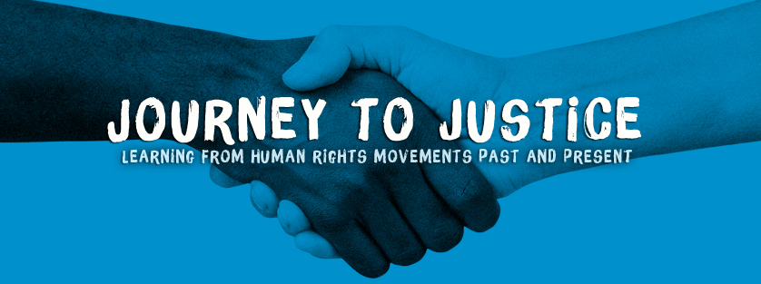

Parental/Guardian Consent Form (to be completed if participant/volunteer is under 18)
[Name] ____________________________ is participating in a Journey to Justice event/project. As they are under 18 we need parental/guardian consent for them to volunteer with the project. Please complete the information below to give your permission.
Name:

Relationship to you:

I, the undersigned, am happy for my child/dependant to participate in the Journey to Justice programme as a volunteer.
Signature:

I agree that photographs, film and audio recordings made of my child/dependant during voluntary activities facilitated by Journey to Justice can be used for publicity and promotional purposes.

Date:
For further information please don’t hesitate to contact:

