Journey to Justice in XXXX Training for volunteers at XXX

Date and time

We’ll send our short films and link to website in advance.

- Introductions – your name and what it means to you and your connection to social justice (in pairs if large group)

- Journey to Justice aims/work/the exhibition - handout about main exhibition, guide, trail.

- Local histories and programme.

- Venue - layout, toilets, café etc, First Aid, point of contact. (Ask staff member to do this. Ideally you will run the training at your venue with the exhibition installed)

- Tour of exhibition and history of civil rights movement.

- Role & expectations of volunteers (activity), what do you think is important about the role? If you were a visitor, what would you expect from volunteers? A chance to discuss interaction with visitors/welcoming them/engaging with them/what to say etc. Practical aspects – tags/sign-up etc. Run role play? (JtoJ)

- Paperwork – photo permission, evaluation/equality forms, expenses form, sign-up, donations, checklist etc.

- Journey to Justice films? and checklist – including encouraging visitors to sign-up and donate/tour of exhibition

- Evaluation of training

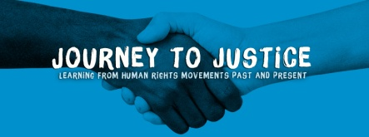

Journey to Justice training for XXXXX volunteers XXX (date)
- Any comments about the organisation, venue or refreshments?

- Did you have enough information about JtoJ and the exhibition before the training day? If not, please say what you would like to have known/been sent.

- Did you feel prepared for your role as a volunteer by the time you left the training session? Please explain your answer.

- Which part(s) of the session were most memorable for you? Why?

- Overall, how much did you enjoy the training? 1 = Not a lot 5 = Enjoyed it a lot

1 2 3 4 5

Any comments?

- Do you have any suggestions about how we could have improved the session?

- Any other comments?

Thank you very much

