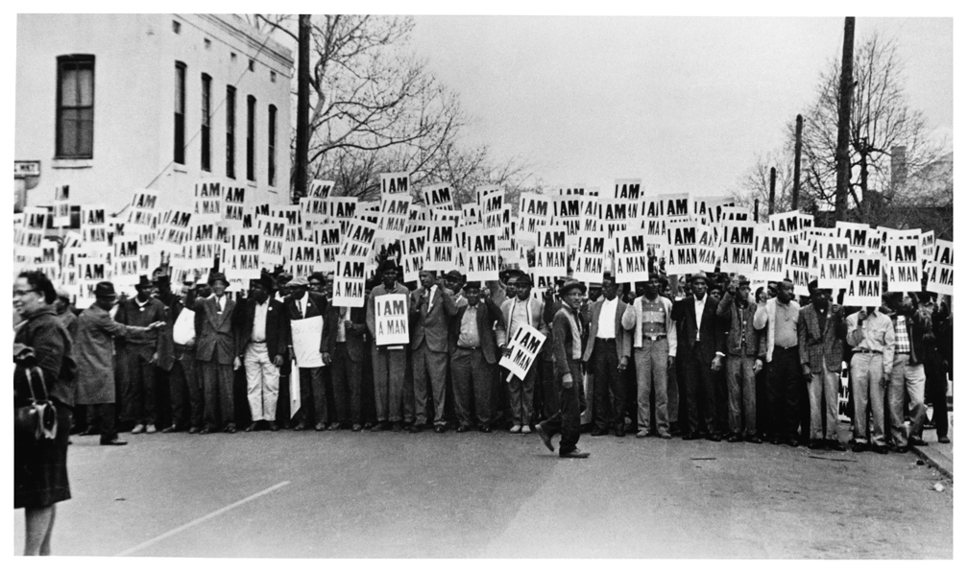
‘I am a man’ – Memphis Sanitation Workers Strike, 1968 © Ernest C. Withers

FOR IMMEDIATE RELEASE: 20th May 2016
STUNNING CIVIL RIGHTS MOVEMENT EXHIBITION LAUNCH AT THE ART HOUSE SHEFFIELD
SATURDAY 28TH MAY
The UK’s first major exhibition on the US civil rights movement and its impact in the UK opens on Saturday 28th May at The Art House, Sheffield. The launch of Journey to Justice, a unique and powerful multimedia exhibition, marks the 50th anniversary of the two-year stay in Sheffield of Dr. Preston King, a leading American academic and noted civil rights advocate.

The exhibition, created by human rights organisation Journey to Justice, tells the story of both famous and obscure civil rights heroes whose courage and tenacity challenged American segregation and racial violence. Opening the launch will be Father Grant Naylor, priest of St. Matthew’s Church and performers include Grammy-nominated Steve Edwards. Speakers will include representatives from Sheffield Amnesty, Sheffield Environmental Movement and Romano Jilo, Nikki Sharpe, Shahnaz Ali and Paul Blomfield MP.

Uniquely, the exhibition highlights the links between the US movement and social justice struggles in Sheffield. In 1964 Sheffield University played host to a visit by Malcolm X. The city was one of only three places outside of London where he spoke. In his speech Malcolm X said “We are not fighting for civil rights, we are fighting for human rights. Freedom is a valuable thing.”
The region of South Yorkshire has a proud history of speaking out for social justice campaigns.
Sheffield was a leading light in the struggle to end slavery in the 19th century. The first call for female suffrage was also made in the city. In more recent times Sheffield has been a hub for the Anti-Apartheid Movement and the Asian Youth Movement. Along with the once-described ‘political refugee’ Dr Preston King, the city has also welcomed to speak within its walls the likes of Olaudah Equiano, Paul Robeson and Anwar Ditta.

Working with a steering group and partners including Sheffield City Council, both Universities, trade unions, youth and community groups, artists and musicians, Journey to Justice will offer a month-long rich programme of events: courses, walks, talks, music and film to complement the exhibition as part of its mission to galvanise people to take action for social justice.
Journey to Justice is a national volunteer-led alliance of educators, artists, historians, young people, lawyers, human rights activists, media workers and faith representatives. Through education, music and the arts, Journey to Justice illustrates historical and contemporary human rights struggles from around the world to show how grassroots movements can bring about profound and sustained social change. The exhibition will continue to tour the UK after its stay in Sheffield.

Notes to editors
For launch details, information, quotes and images contact XXXX Tel. XXX for the full programme of Journey to Justice events: www.journeytojustice.org.uk
For details of Journey to Justice’s national work contact XXXXXX
- Journey to Justice is a charity (No. 1170886), funded through the Heritage Lottery Fund, the Sigrid Rausing Trust, Trusthouse Charitable Foundation, the Big Lottery Fund, the Cultural Affairs Department of the US Embassy, Evan Cornish Foundation Sheffield Grammar School Exhibition Foundation, Sheffield Town Trust, Children’s Acupuncture Clinic, Sheffield Hallam University, crowd funding and personal donations. Kindly hosted by The Art House with hours of in kind support from other local partners and volunteers.
Web: http://journeytojustice.org.uk/
Twitter: @freedomandjobs #sheffieldvoicesforequality
Facebook: www.facebook.com/journeytojustice.org.uk

- Dates: Exhibition and programme run Saturday 28th May- 25th June 2016
Launch Event: 28th May 12:00-13:00; Ribbon cutting 13:15 pm; Private View 13:30-17:00.
Launch Venue: St. Matthew’s Church, Carver St. S1 4FE.
Launch event tickets: Free, booking essential www.ticketsource.co.uk/date/254142
Exhibition Venue: The Art House, 8 Backfields, S1 4HJ (Free)

Tickets: Most events are free, book tickets here: www.ticketsource.co.uk/journeytojustice1

- Patrons: Journey to Justice is supported by high profile patrons:
- Baroness Helena Kennedy QC
- Lord Herman Ouseley, former Chair of Commission of Racial Equality, founder of ‘Kick It Out’
- Sir Geoffrey Bindman, QC (son of Tyneside), human rights solicitor
- Leyla Hussein, co-founder of Daughters of Eve, anti-FGM campaigner
- Dr Paul Stephenson, leader of the successful 1963 Bristol bus boycott
- Jean Stallings, civil rights and anti-poverty campaigner

- Local partners include: Sheffield City Council, UNISON, UNITE, Sheffield University, Sheffield Hallam University, Development Education Centre (DECSY), Eclipse Theatre, Side by Side, Weston Park Museum, Sheffield Amnesty International, Football Unites Racism Divides (FURD), Sheffield TUC, Friends of Edward Carpenter, St. Matthews Church, the Art House, Romano Jilo, Sheffield Climate Alliance, Sheffield Libraries, Archives and Information, Sheffield Environmental Movement,.

#socialjustice #civilrights #exhibition #Newcastle #rights #history #humanrights #footstepstofreedom #justice

