Journey to Justice – Equality
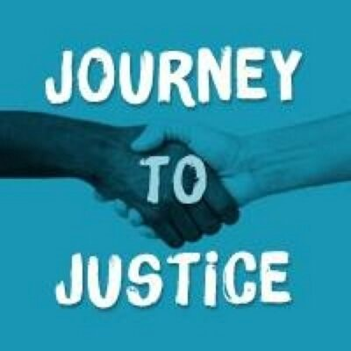

Journey to Justice wants to reach as wide a range of people as possible, so we would
be very grateful if you would answer these questions. All the responses are anonymous
and they will only be used for the evaluation of Journey to Justice.

Age
 | How old are you?
 | Do not wish to give this information
Gender |  | Tick
 | Male
 | Female
 | Other
 | Do not wish to give this information
Ethnic Origin
White
English / Welsh / Scottish / Northern Irish / British
Irish
Gypsy or Irish Traveller
Any other White background, please describe:
Mixed / Multiple ethnic groups
White and Black Caribbean
White and Black African
White and Asian
Any other Mixed / Multiple ethnic background, please describe:
Asian / Asian British
Indian
Pakistani
Bangladeshi
Chinese
Any other Asian background, please describe:
Black / African / Caribbean / Black British
African
Caribbean
Any other Black / African / Caribbean background, please describe:
Other ethnic group:
Arab
Any other ethnic group, please describe:
Disability
Do you consider yourself to have a disability? | Yes
 | No
 | Do not wish to give this information
Sexual orientation
 | Heterosexual or straight
 | Gay male
 | Gay female or lesbian
 | Bi-sexual
 | Other
 | Do not wish to give this information
Religious belief
Do you have a religious belief? | Yes (please specify):
 | No
 | Do not wish to give this information

