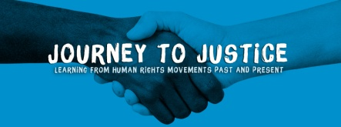

Volunteers’ case study template

Your name:

Your age:
(At time of volunteering and present day)

Location - where you volunteered:

Name of volunteering project:
Dates volunteering took place (months and years):

Your contact details: Email & phone number

Case study (include current date)
I confirm that all individuals named in the case study have read and signed the consent form (Please attach when submitting your completed case study).

Questions to ask case study

- Name, age, address (town, city, village) and contact details as above

- What were you doing before you started volunteering?

- How did you find out about Journey to Justice?

- What inspired you to volunteer?

- When did you volunteer? Dates?

- What kind of the challenges did you encounter when you started volunteering?

- What skills do you think you have developed through volunteering?

- What do you gain from volunteering?

- Why does volunteering matter to you?

- What are you doing now? If you’re studying, where and what are you studying? Has volunteering helped get you there? If so, how?

Case Studies Tips

- Case studies should ideally always be written in the first person “I…”

- Remember to engage your readers and tell a story with a strong angle. Maybe combine a career interest with a human element, such as how becoming a volunteer on a Journey to Justice exhibition programme fits with your personal aims.

- Write in a clear, simplistic format.

- Always ensure that the case study is aware that the copy will be used both internally and for external PR purposes.

Photography Tips

- Photography must be included with the case study

- Good photography in necessary for a strong case study.

- Always check and secure signed permission to photograph the beneficiary.

