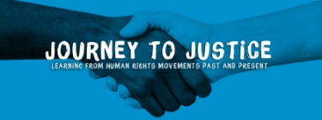

Journey to Justice: Youth and Community Projects

‘We are caught in an inescapable network of mutuality, tied in a single garment of destiny. Whatever affects one directly, affects all indirectly.’ (Dr. Martin Luther King, Jr. 1963)
Journey to Justice (JtoJ, Charity No. 1170886) is a UK based human rights education organisation whose mission is to galvanise people to take action for social justice through learning about human rights movements and the arts. The general direction of the organisation and the coordination of its UK-wide activities are determined and managed by a management committee (MC) with a chairman and elected officers working with Director, Carrie Supple who is based in London. JtoJ has active regional steering groups throughout the UK which work closely with the national MC to plan and deliver activities and events that meet the aims of the organisation. Despite the presence of a formal organisational structure, JtoJ is a volunteer-centred organisation that values and thrives on partnership and the drive and enthusiasm of volunteers, dedicated to taking action in order to bring about positive change. JtoJ strikes a chord with people whichever social justice issue they are concerned about whether racism, domestic violence, poverty or the elderly.

JtoJ’s flagship project explores how advances in the protection of individual rights are hard won and cannot be taken for granted. We created a multi-media, interactive travelling exhibition focused on the US civil rights movement, its universal significance and its links to the UK including the Bristol bus boycott, 1963. It tells stories of less well-known men, women and children who were involved (via a series of ‘bus stop’ installations) and explores factors essential for a human rights movement to succeed. A juke box of freedom songs plays throughout and the exhibition includes art and poetry. The exhibition makes links to the tradition in the UK of struggles for fundamental freedoms.
The travelling exhibition is a catalyst for a complementary programme of education and arts based workshops and events that harness local energies and histories by working with a vast range of voluntary and community organisations who plan the programme - taking a different form in each place. As it tours, JtoJ connects with and invigorates people to develop a ‘sense of agency’, see that change is possible and work for human rights. The exhibition has toured to Newcastle, Sheffield, Middlesbrough, Sunderland and Tower Hamlets and is now at Morley College, Lambeth (Jan. 9th – Feb. 3rd 2017). It has been booked for Nottingham, Hull, Bristol, Dorchester and Leicester with interest from many other places. Since its launch in 2013, JtoJ has reached thousands of people via the travelling exhibition programme and has worked in partnership with schools and youth and community groups from diverse locations, independently of the exhibition as well.
This document is to present a small selection of the projects we have run so far. See the JtoJ website (http://journeytojustice.org.uk) for an in-depth overview of work carried out by the organisation.

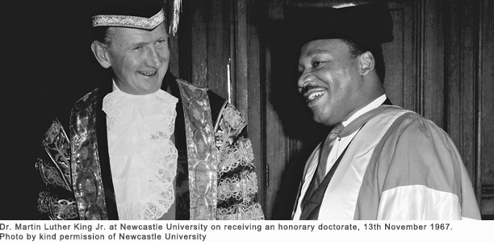
Dr. Martin Luther King, November 1967 receiving an honorary degree from Newcastle University
A Way Into Our World, June 17th 2015, The JtoJ Poets of George Mitchell School, Leyton

George Mitchell School hosted a remarkable evening of poetry written and performed by a group of its Y7-10 students. They worked together for months supporting each other and creating poetry so powerful it has been published and featured by Exposure, an award-winning youth organisation and in a local newspaper and is a permanent part of our travelling exhibition. Their teacher and current vice-chair of JtoJ, Parul Motin, inspired by the Journey to Justice launch in London, set up the poetry club in winter 2014. She identified young people she thought needed support or lacked confidence or for whom English is an additional language. They visited galleries, talked about the meaning of social justice and human rights in history and today, studied poetry, ballads and free verse and from their experiences, observations and feelings, the extraordinary poems flowed.
For Parul, the JtoJ poetry club has enabled her to work in the way she loves most. Students who had been too shy to speak, began to join in and interact. They worked as a team and were less afraid to make mistakes. One said, “usually only kids called ‘gifted and talented’ kids do this.” Another told the Head, Saeed Hussain, how much fun they were having and he visited the club and saw their progress. Parents said their children were more confident and positive, reading their poems aloud at home. Many came to the performance – a moving and inspiring event. The poems were about difficult issues – racism, isolation, arranged marriages, family conflict and sexuality. ‘The young people showed bravery, intelligence, creativity and a commitment to change.’ (Pat Boyer)
“I was nervous but excited, I was able to show my talent. I don’t speak much and everyone thinks I’m shy but they saw me differently that night.” (Nazifa)
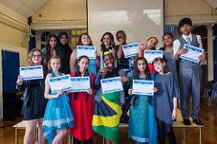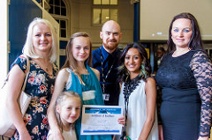
JtoJ Live – combining history, the arts of social protest and an understanding of social change January –July 2015 20 young people, all of whom had been identified either as in danger of becoming ‘NEET’ or who were in some way vulnerable, had an opportunity to learn in a totally new way. The sessions were carefully planned and rigorous but in an informal environment with high adult: young people ratio and the vast majority of young people thrived in such an atmosphere. They learned about non-violent struggles for human rights in history and now, they met activists for decent housing, studied music and poetry of social protest and wrote and performed their own - some of which was published. They attended a preview screening of Selma and shared a platform with our patrons Baroness Helena Kennedy and Lord Herman Ouseley and Chi Onwurah MP. They saw a searing production of The Scottsboro Boys and a leading actor from the show, Brandon Victor-Dixon, visited and advised them afterwards. They visited the Adopting Britain exhibition at the South Bank Centre and worked with Movement for Change to develop their own campaigns. We organized a celebration at the House of Lords, hosted by Lord Herman Ouseley and Lord Jeremy Beecham. The young people made presentations about their project and learning to a roomful of guests including members of the Lords, film makers, theatre directors, former civil rights activists and many other supporters.
‘I left there so proud. I never saw myself making a speech. I think we got their attention and we got them to feel they want to follow the campaign’ (participant). Our evaluation shows that participants developed a deeper understanding of key concepts such as social justice, human rights and activism and, most vitally, of their own ability/right to be heard and make an impact. 90% of the group achieved an ASDAN qualification: ‘Our voice is the next generation, there are people too scared to say what they think and we have to be role models.’ ‘Since I joined JtoJ I had the confidence to make a change and speak out. I learned a lot about who changed history.’ ‘I was proud of myself because I was never able to speak in front of a lot of people but JtoJ gave me confidence and helped me every step of the way.’ ‘Justice is important. We need to be treated fairly and be happy.’ ‘It’s making me understand more about society. I can get things off my chest. I can help younger people understand better about gangs.’ (This project was funded by the Big Lottery Fund, Awards For All)
Poverty Ends Now, Children North East, Newcastle, April 2015
A two-day training session was organised for young people who are already active in social justice campaigning but had not yet had any formal training. 11 young people from Children North East (plus two members of staff) attended our training sessions about non-violent community organising skills run by Jack Madden, formerly of Movement for Change, and Martin Spafford of Journey to Justice, an experienced history teacher. The young people were involved in Poverty Ends Now (a campaigning organisation for young people, http://www.children-ne.org.uk/pen-poverty-ends-now-%E2%80%93-children%E2%80%99s-manifesto-poverty , Newcastle Youth Council and Youth Focus North East. The young people’s responses show that their knowledge, confidence and understanding about community organising, campaigning and effecting change increased significantly as a result of the training. PEN immediately started putting into practice some of the things they had learned, notably the need for developing a strategy. “This is the first training I’ve attended which inspired me to do something. It was really good. We know what the next part of our campaign is now. It was good last year [when we went to Parliament, met MPs and were listened to] but it didn’t achieve any change.” (This project was funded by the Trusthouse Charitable Foundation, Barbour Foundation and Newcastle’s preview screening of Selma)
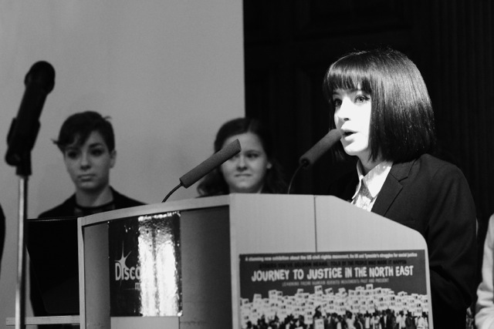
Members of Poverty Ends Now speaking at the Journey to Justice launch

Sheffield, Eclipse Theatre writing workshop, June 2016
Dawn Walton, Artistic Director of Eclipse Theatre (most recently A Raisin in the Sun) ran a session looking at the craft of writing as part of Sheffield JtoJ Voices 4Equality programme. Dawn has a wealth of experience and achievement and runs a successful touring company based at the Crucible Theatre in Sheffield. She has championed opportunities (e.g. Cultural Young Ambassadors) for those with talent, especially new writing, from within black and minority ethnic communities. She ran a session for young people aged 15-19 who have a passion for writing, whether for the theatre, film or human rights. Participants were stimulated, challenged and stretched in a lively supportive environment. ‘It shows that people can make a difference by being non-violent.’
Alternative Provision at CandI, City and Islington College, June 2016
In June 2016 JtoJ facilitators worked with nine young people at CandI. In prior discussion, they identified their lack of confidence in interviews and belief that employers would not want to hire them. JtoJ’s focus, therefore, was on developing confidence and skills. As a starting point we used stories of campaigns for justice including the Hillsborough Families and British children forcibly migrated to Australia in the 1950s and 1960s. We shared examples of music and spoken word about overcoming challenges (Suli Breaks, MC Naga, Sam Cooke) and identified their own positive qualities. The students also shared their own choices including Akala and South London rapper Dave. We then worked with them individually and in small groups so that each young person could develop a strong body of truthful, positive achievements, skills and values they could back up with evidence from their own lives. Their challenge was to undergo a formal professional interview and communicate those skills successfully. On the last day, people from the worlds of journalism, advertising, business and education interviewed them and fed back their highly positive observations to each young person. All those interviewed achieved a 4 or 5 for employability (where 5 was the highest). Not only had they proved to themselves that they could successfully impress employers, but they had brought from hibernation strongly positive aspects of their own personalities that they could be proud of and express with confidence. “You guys gave us confidence to do well, despite our incidents at school… It’s given me motivation to do more about what I want for my future.” “Justice doesn’t just come. You go through trials, that’s part of the road.” “We can make a change by promoting equality and telling younger people about these stories, so they can learn from them. We have to stick up for each other.” “Everyone had fun. Journey to Justice people made us feel at ease and cared for us, you didn’t judge us.” (JtoJ was employed by Islington Council to run this project)

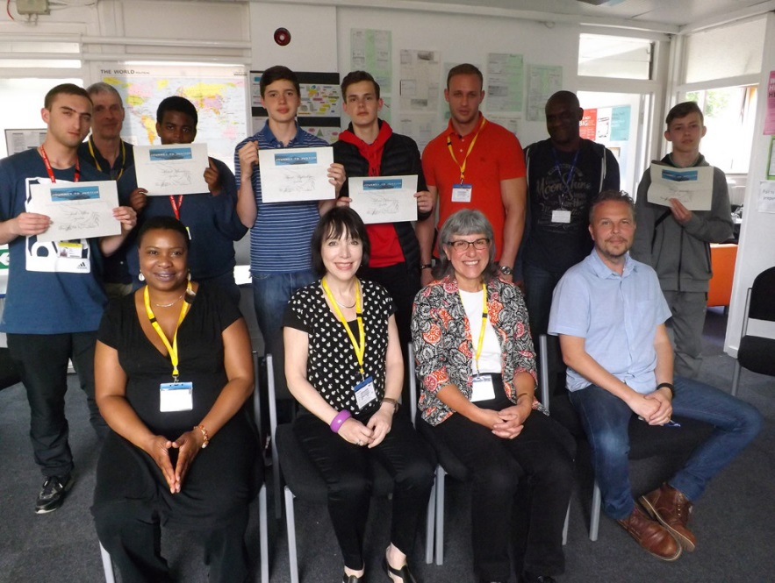
Young people, staff, interviewers and JtoJ at CandI

Girlz United, Shadwell, Tower Hamlets, July 2016
JtoJ partner Girlz United – a young women’s community group with Muslim members - were keen to meet their peers from backgrounds different to their own and to learn about the local East End history of struggles against racism. Julie Begum, Chair of the Swadhinata Trust, met the girls in early July to talk about her role in Women Unite Against Racism in the 1990s and about the murder of Altab Ali in 1978. On July 15th-17th Girlz United went away with members of Hawkwell Girls Brigade, Essex and Brandon Baptist Church, Camberwell for a residential weekend in Danbury, Essex. Led by youth workers and facilitators, Leanne Sedin, Liz Anderson, Parul Motin and Sally Claydon they focused on questions of identity, social justice and team building, producing beautiful poems for our exhibition in Tower Hamlets and made three stunning presentations at JtoJ events in the borough.

“What we’ve done together this weekend is important not only through the practical activities, I also gained knowledge and it’s inspired me to become more of an active person and to start taking more interest in my own community and value every piece of it.” ”Without programmes like this people are unable to understand why people are racist. It is fear of the unknown.” “We learnt that we all have a voice. It’s just what we do with it that can make a difference.” “This project has been so emotionally powerful.”"This weekend shows how people don’t all have to be the same to get on which is something I rarely see at school.” (This project was funded by the US Embassy, London)
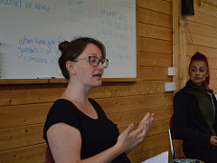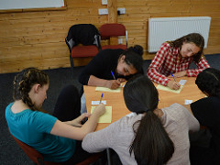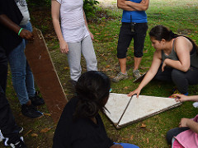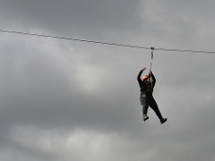

Visit of Jean Stallings, veteran civil rights and anti-poverty campaigner, December 2016
Jean Stallings, a veteran civil rights and long time campaigner against poverty, joined JtoJ from New York for twelve days with her granddaughter Briana in December 2016. She opened the JtoJ travelling exhibition at Rich Mix, Tower Hamlets on Human Rights Day and ran workshops for young people, teachers and community workers in the East End of London and in Sunderland and visited the room where Martin Luther King received an honorary degree in 1967 from Newcastle University.
“We had dignity. The War on Poverty in the early 1970s helped us women. We got jobs, they put us in training programmes for people on welfare, they provided childcare and a community center. The National Welfare Rights Organization propelled me to go on to other things – I got my education and volunteered in different things. That voice for change was in me and I went on. It’s so important to feel part of something. It doesn’t have to be big – you don’t have to be famous. You just have to give a part of yourself. I wasn’t a leader but a little seed – I had a voice. I learned to speak without fear.”
Her audiences here were rapt and many moved to tears. Wherever she went she touched people’s hearts and was overwhelmed by their response. (This project was funded by the US Embassy, London and BAAS, British Association of American Studies).
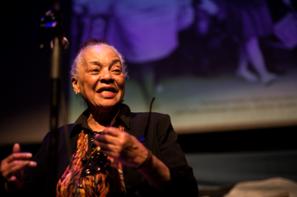
Jean Stallings, JtoJ patron
Hidden Histories – Sunderland, autumn 2016
Hidden Histories is a ceramics project completed in partnership with MBC Ceramics. The piece was completed with the help of sixty participants from six community groups across the Sunderland area: The Bangladeshi Centre, Sangini, Pennywell Probation Service, Washington Sunderland Care and Support, Leechmere Sunderland Care and Support and Fulwell Sunderland Care and Support.
The result is a beautiful piece of artwork that is now touring Sunderland so it can be enjoyed by people from all over the city. Inspired by a local geological formation, cannonball rocks secreted from limestone, the installation captures the true essence of a hidden history and evokes the city’s maritime history. Participants were taught about less told stories of social justice in Sunderland’s history including about abolition, pacifism, and women’s rights in order to inspire them to think about their own journeys and stories of social justice. The participants were asked to write stories about their own journey to justice or their experience of social justice in the city.
They were then encased in clay spheres which were kiln-fired to form the cannonballs. Each individual cannonball was decorated in order to personalise the sphere and give an insight into the person who made it. With the stories cased inside the clay sphere, this reflects that the everyday image we project on the outside may not always reflect what is happening inside. The stories told were powerful, moving, evocative and inspiring and can be shared in various locations throughout Sunderland including Sunderland (FE) College and the Interfaith Chaplaincy Centre.
