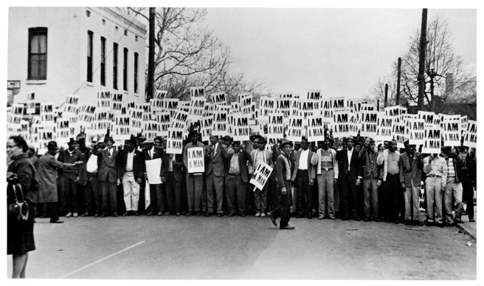
Local photo???

t Memphis sanitation workers’ strike, 1968 © Ernest C. Withers

Help us bring Journey to Justice to XXXXX
Journey to Justice is an organisation whose mission is to galvanise people to take action for social justice through learning from human rights movements and the arts.
The Journey to Justice touring exhibition tells extraordinary stories of ordinary men, women and children involved in the US civil rights movement and connects that history to struggles for freedom in the UK. This multi-media, interactive, exhibition explores the question ‘What leads people to be active in all kinds of human rights campaigns?’ As the exhibition travels around the UK, Journey to Justice is partnering with local organisations and communities to run programmes of arts and education events, telling local stories of fighting for freedom, equality and human rights.
We show how change for social justice can happen led by ‘people like us’.
Join us for a free taster session to discover how this exciting project will become the first exhibition and events programme at XXXX
Date and time
Address
This taster session will introduce the activities, projects and approach of Journey to Justice. We are looking for input and help in bringing the exhibition and programme to XXX in XXX. The project will include uncovering and celebrating XXX’s long history of social activism.
Attendance is free and light refreshments will be provided. Please RSVP or find out more by contacting XXXX name, telephone number, email etc

For more information on Journey to Justice please visit the website http://journeytojustice.org.uk/
Local logos

Journey to Justice: XXXXX Place

Taster session: XXXXXXX Date

At: XXXX address

Chair: XXXX (optional)

Aims

- Introduce you to the work of Journey to Justice: activities, projects, approach
- Showcase the Journey to Justice pilot projects: exhibition programme in the NE, JtoJ Live
- Discuss the possibility of bringing Journey to Justice to XXX
- Identify potential venues, audiences, activities, funding sources.
9.00 to 9.30
Arrival - registration, refreshments, slideshow and music
9.30 – 10.10
Introduction XXXXXX local and XXXX national JtoJ partners

10.10 – 10.30 Exhibition programme and films of JtoJ
10.30 – 11.00 Showcase the Journey to Justice projects

10.50 XXXX local campaigns& what makes an activist?

11.30 Break
11.45 – 12.00 Activity (could be linked to local or national themes)

12.00 – 13.00
Discussion about JtoJ coming to XXX - interest; potential partners, dates and venues; audiences; activities; likely costs; funding sources; local histories of fighting for freedom, equality and human rights. Form steering group? What next? Volunteers, responsibilities? We welcome many different ways to achieve our aims. We want JtoJ to be based in museums, arts centres, schools, community centres, sports clubs, festivals, FE, Universities etc. Chaired by XXX

Evaluation

Lunch (depends on funding)

Journey to Justice taster, XXXXX venue and place
XXXX Date and time Evaluation (PTO if you need more space)

- Any comments about the organisation, venue or refreshments?

- Was there an aspect of the session which inspired you or was most memorable? If so, please say a little more.

- Which part(s) of the session were most useful for you? Why?

- Overall, how much have you enjoyed today?

1 = Not a lot 5 = Enjoyed today a lot

1 2 3 4 5

Any comments?
- Do you have any suggestions about how we could have improved the session?

- Would you like to be involved in discussions about bringing Journey to Justice to XXXX? If so, please leave your contact details and let us know how much time you have and what sort of role you might play.

Thank you very much

