The perfect gift
Just Food
A book of delicious vegetarian recipes chosen by
social justice activists in aid of Journey to Justice*

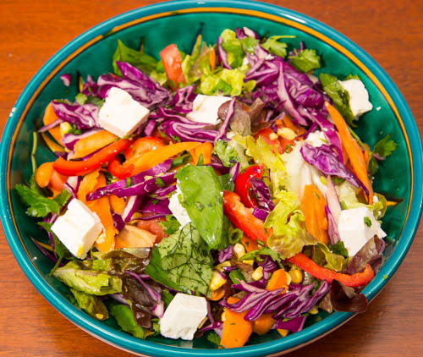

Compiled by Róisín Gewirtz-O’Reilly on the occasion of her Bat Mitzvah

Nine recipes including: Deborah Lipstadt’s Fresh Salad; Anat Hoffman’s Devilled Eggs; Jean Stallings’ Cornbread; Focus E15’s Kerala Style Egg Curry with Coconut Milk. “It’s a myth that eggs are bad for your heart” (British Heart Foundation)

Please complete the form overleaf for your copies, only £5 each

*A national volunteer-led human rights education charity, JtoJ is an alliance of educators, young people, community, human rights and faith groups, artists, musicians, trade unionists and historians. Its aim is to galvanise people to take action for social justice through learning about human rights movements and the arts. www.journeytojustice.org.uk
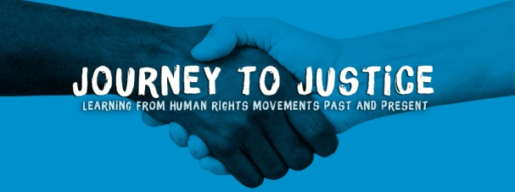

Please complete the form and email: roisinbatmitzvah@gmail.com or post to address below
Please send me [ ] copies @ £5 each
Plus: Post & Packing: £1 (for 1 copy); £4 (5+ copies) Overseas: £5.00 (sorry)
Plus a donation to JtoJ if you would like to: £
Total: £

Name:
Postal address:

Email:
Tel:
Please send a cheque payable to Journey to Justice and post it to:
10 Carleton Gardens, Brecknock Road, London, N19 5AQ
Or you can pay into the Journey to Justice account Add Róisín’s name to yours when asked for payee details e.g. ‘Martha Brown Roisin’ so we can identify orders
Account Name: Journey to Justice Lloyds Bank
Account No: 53525160 Sort Code: 309897

