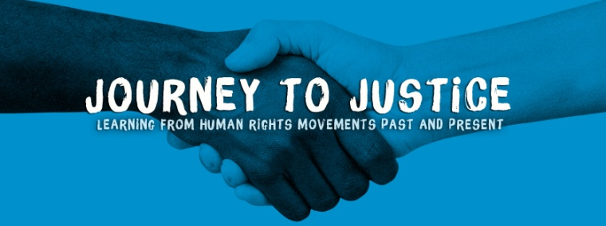

www.journeytojustice.org.uk

Vision Everyone feels responsible for social justice and is active in promoting and ensuring it.

Mission To galvanise people to take action for social justice through learning about human rights movements and the arts.

VOLUNTEER OPPORTUNITY TITLE & MAIN TASKS | Volunteer Co-ordinator: overseeing the recruitment, progress and welfare of JtoJ volunteers (could be a job share). You will help interview applicants and develop their role descriptions then support them with six monthly 1:1 meetings to review progress.
VENUE | Mainly home based, we meet in cafes.
JTOJ VOLUNTEERS | Our volunteers play a significant role in the work of Journey to Justice including: research, fundraising, running workshops and training, PR, marketing and communications, event and project management.

FOR EXAMPLES OF VOLUNTEER STORIES & A SHORT FILM:

https://journeytojustice.org.uk/about/volunteer-stories/

FOR OUR VOLUNTEERS' HANDBOOK:
https://journeytojustice.org.uk/volunteer_handbook/

WHEN REQUIRED – flexible. Approximately 2-4 hours per week.

START DATE FOR VOLUNTEER OPPORTUNITY: mid-Sept. 2019 END DATE: to be agreed

Volunteers come to us because, to quote volunteer Alejandro Guzman, 'JtoJ ignites the flame in everyone’ and as former Journey to Justice Volunteer Coordinator Tania Aubeelack says, ‘JtoJ is the bridge between my beliefs and my action – it gives me a platform.’ People give to JtoJ in so many ways with their time, their homes, donations, ideas and skills.

DESCRIPTION OF VOLUNTEER OPPORTUNITY

Journey to Justice is a volunteer run human rights education charity. We have a large, ever growing number of volunteers working with us and now seek someone to co-ordinate the process of: their recruitment (advertisements, applications, interviews, references etc) and induction; agreeing aims and role descriptions; assessing their progress and experience and welfare.

This could be a great opportunity for someone (or two people) to develop their skills and career prospects.

There will be an opportunity to revise our induction process and volunteers’ handbook and perhaps a newsletter for JtoJ volunteers.

The Volunteer Co-ordinator will work with members of the trustee board responsible for appointing volunteers and you will receive support from the Director and other trustees.

We have volunteers all over the UK but this role is for our London based team only, initially.

SKILLS / QUALIFICATIONS REQUIRED

No specific qualifications required

Must be committed to JtoJ Vision and Mission.

Must be reliable and punctual and deliver agreed goals.

Communication
Candidates must have excellent communication skills (verbal and written) and access to a reliable computer. Ability to work with and engage others and to win their trust.

Record Keeping
Ability to maintain clear and accurate confidential records.
Good administrator. Excellent skills in Microsoft Word and Excel.

Working together
Proactively enables and encourages team work in others. Ability to build up trust with a team and partners, whilst maintaining a professional relationship and confidentiality.
Ability to work creatively and collaboratively, in partnership, with individuals and other organisations.

Independence Self motivated and can work alone

Contact: Carrie Supple, JtoJ Director, carrie@journeytojustice.org.uk for an application form.

