

**Mary and Pat are walking for Journey to Justice!**

**October walks for Journey to Justice have been taking place to celebrate wonderful women (past and present) who have taken action for social justice. We’re also raising funds for our Economic Justice Project- see our website** [www.journeytojustice.org](http://www.journeytojustice.org).uk

**We’ll be walking along the Thames (south bank) on Sunday 1st November (almost October!) through Bermondsey to celebrate Ada Salter.**

**She dedicated her life to** the transformation of Bermondsey from industrial slum to green oasis. A Quaker and an ethical socialist, she felt her mission was to deal with the great iniquity of slum housing and the intolerable conditions in which the urban poor were forced to live. She arrived in Bermondsey as a social worker where she met her husband, Dr Alfred Salter. Together they lived in the slums among the people they represented and helped, he providing medical assistance to the poor and needy while she threw herself into alleviating social injustices affecting housing, health, worker’s and women’s rights.

Ada Salter became Mayor of Bermondsey in 1922. She was one of the first female mayors in the country, and was the first ever female Labour mayor. From this platform, she and her fellow councillors were able to set in motion a whole host of radical policies and reforms. Great strides in public health were made decades before the NHS existed, a programme of slum clearance alongside the erection of new homes, vastly improved sanitation, and public washing and laundry facilities were completed.

**But perhaps Ada’s most long-lasting and far-reaching achievements were those of the ‘Beautification Committee’ she chaired from 1919. This task force was driven by the compulsion that improving the environment was part and parcel of improving people’s lives, and that by raising aesthetic appreciation of their neighbourhoods, a sense of personal wellbeing and civic pride would be engendered. Salter’s ambition with the Beautification Committee was to turn Bermondsey into nothing less than a garden city.**

**To sponsor our walks for economic justice, please go to:**<https://localgiving.org/appeal/economicjustice/>

**Our target is £1,500!**  £1,425.00 raised as at October 27th – thank you all, very much indeed, your support means everything. **Nearly there!**

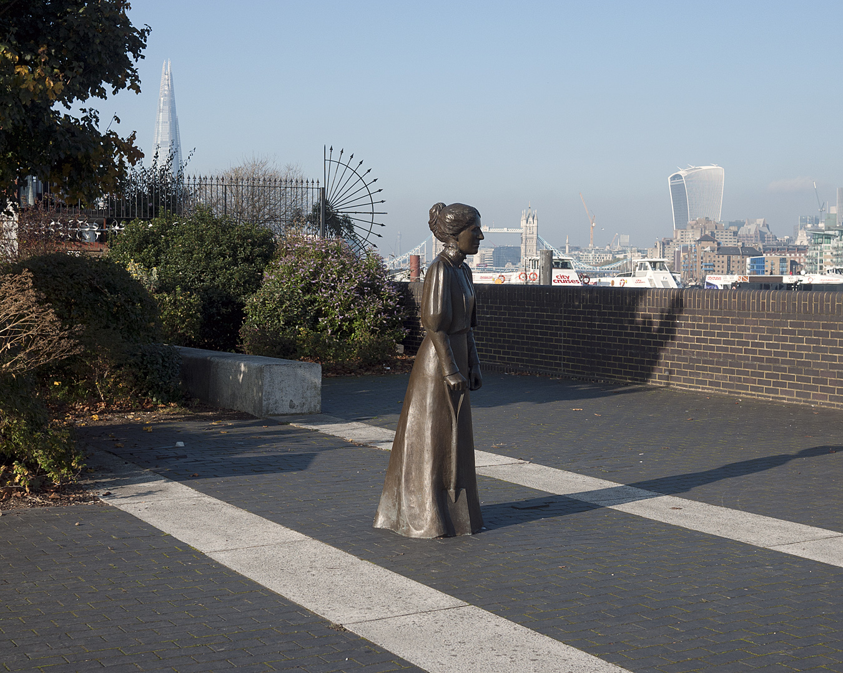

**Ada’s statue at Bermondsey Wall**

**‘Tree of Heaven’ planted above the vault where Ada & Alfred’s ashes are buried**

**in the Fair Street Estate**

